26.76: a) 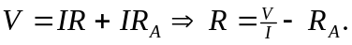 The true resistance R is always less than the reading because in the circuit the ammeter’s resistance causes the current to be less then it should. Thus the smaller current requires the resistance R to be calculated larger than it should be.
b) 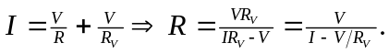 Now the current measured is greater than that through the resistor, so 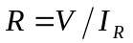 is always greater than 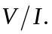
c) (a): 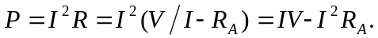
(b):

